Form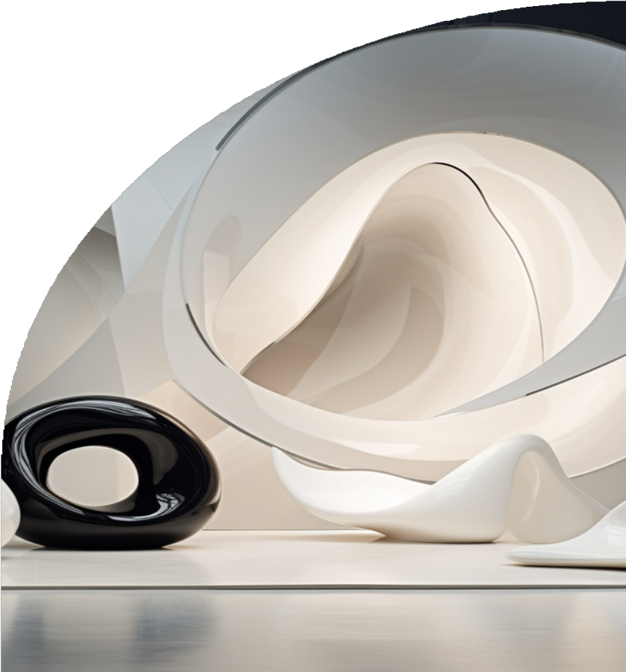



Understanding Form as an Interior Design Element

# Categories of Form:

Forms can be categorised into three primary types:

1. **Geometric Forms:** These are precise, regular shapes such as squares, rectangles, circles, and triangles (Fig. 2). Geometric forms often convey a sense of order, stability and modernity. For example, a square coffee table or a circular mirror. These forms are often found in Contemporary Interior Design Styles.
2. **Organic Forms:** These are irregular, often asymmetrical shapes that mimic the forms found in nature (Fig. 3). They tend to create a more relaxed and flowing atmosphere and are associated to comfort and connection to the natural environment. Examples include the curves of a chaise lounge or spiral stiarcases.
3. **Abstract Forms:** These forms are not immediately recognisable and are often based on artistic interpretations rather than real-world objects (Front page). Abstract forms can add a unique and creative touch to a space, often serving as focal points or conversation pieces. Examples include avant-garde art pieces or unconventional furniture designs that do not conform to typical geometric or organic shapes.

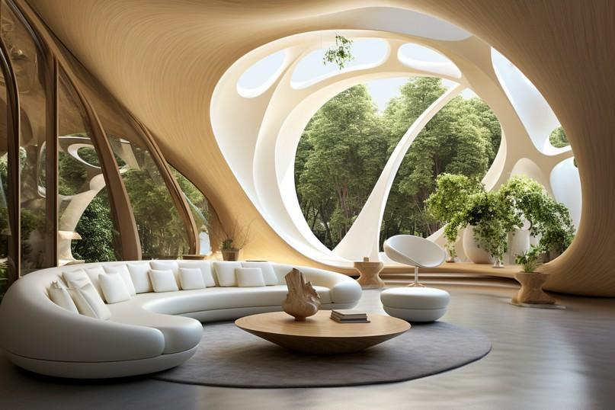

Fig 3. AI generated (2024): Interior Space with Organic Forms.

# Trends and Innovations in Form

## Sustainable Design

Modern interior design often incorporates forms inspired by sustainability, using recycled materials or natural shapes. Designers are increasingly mindful of the environmental impact of their choices, opting for materials and forms that reflect sustainability. For example, furniture made from reclaimed wood or recycled moulded plastic often features organic forms.

## Technological Integration

The advancement of new technologies allows for innovative forms in furniture and decor, such as 3D-printed shapes, that were previously impossible to achieve. Technology enables designers to experiment with complex forms, and customise pieces to fit specific needs and aesthetics. This innovation leads to unique, personalised designs, that push the boundaries of traditional forms.



Fig 5. Canva (nd): Left: Open Form bed, Right: Closed Form bed

# Principles for Using Form in Interior Design

Effectively utilising form in Interior Design requires a thoughtful approach, that balances aesthetics with functionality. The principles of using form involve strategies that ensure the shapes and structures within a space work harmoniously together. By applying these guidelines, designers can create interiors that are visually cohesive, engaging, and practical. Here are key principles to consider when incorporating form into interior design:

## Balance

Maintaining balance in form within a space helps create a cohesive look. For instance, using mostly geometric forms can enhance a modern, minimalist aesthetic. Balance ensures that all elements work together harmoniously, contributing to a unified design. When forms are balanced, they provide a sense of order and coherence that is visually pleasing.

## Contrast

Introducing contrasting forms can create dynamic and engaging interiors. For example, pairing a round coffee table with a rectangular sofa can create visual interest and highlight the unique characteristics of each piece. Contrast can be used to draw attention to specific areas and create focal points. This principle adds depth and complexity to a design, preventing it from becoming monotonous.

## Proportion and Scale

Ensuring that forms are proportionate and appropriately scaled to the size of the room and other elements within it is vital for a balanced design. Oversized furniture in a small room can feel overwhelming, while too-small pieces can get lost in a larger space. Proportion and scale help maintain visual balance and functionality. Properly scaled forms ensure that each element in the room contributes to a harmonious overall composition without overpowering or underwhelming the space.

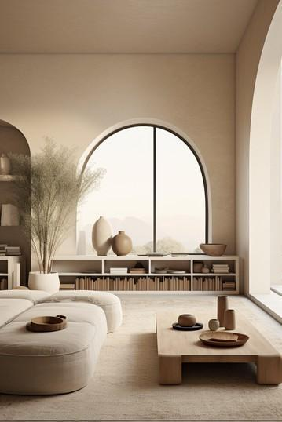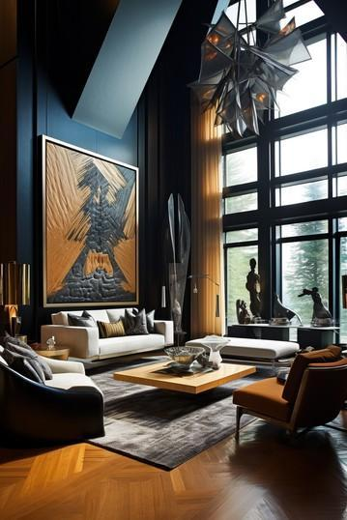

Fig 5. AI generated (2024): Images showing Geometric, Organic and Abstract form in application

# How to Apply Form in Interior Design

Form can be manipulated and combined to achieve various design goals. Here are some practical ways to apply form in interior design:

## Creating Balance:

 Symmetrical Balance: Achieving balance by placing identical forms on either side of a central axis. This method creates a sense of formality and order. For example, positioning two identical armchairs on either side of a fireplace can create a harmonious and balanced look.

 Asymmetrical Balance: Achieving balance by using different forms in a way that still creates visual equilibrium. This approach is more dynamic and adds interest to a space. For example, balancing a large sofa with two smaller chairs and a coffee table can create a visually appealing arrangement that feels balanced without being identical on both sides.

## Enhancing Functionality:

 Consider the form of furniture in relation to the human body, and the intended use of the space. Ergonomic forms in office chairs, or the rounded edges of a dining table can enhance comfort and usability.

## Adding Visual Interest:

 Mix different forms to create a visually engaging space. Pairing geometric forms with organic ones can add contrast and depth. For example, a room with a rectangular dining table can be softened with curvy dining chairs.

 Use form to guide the eye through a space. A series of arches in a hallway or a curved pathway can lead visitors from one area to another.

## Establishing Focal Points:

 Use dominant forms to draw attention. A large, sculptural light fixture, or a uniquely shaped piece of furniture can serve as a focal point in a room.

 Contrast forms to highlight specific areas. For example, a sleek, modern coffee table will stand out against a backdrop of more traditional, ornate furnishings.

**Practical Examples**

Living Room:

 Geometric Form: A modular sofa with clean lines paired with a square or rectangular coffee table creates a sense of order.

 Organic Form: Introduce a statement piece like an irregularly shaped rug or an abstract sculpture to add softness and intrigue.

 Abstract Form: Incorporate an avant-garde art piece or an unconventional furniture item to add a unique and creative element to the room.

Bedroom:

 Geometric Form: A bed with a rectangular headboard and matching side tables reinforces a structured look.

 Organic Form: Curved bedside lamps or a round mirror above the dresser can soften the space and add a touch of elegance.

 Abstract Form: Use abstract wall art or an unusual lamp design to inject personality and interest.

Kitchen:

 Geometric Form: Use of rectangular cabinets and countertops for a sleek and functional workspace.

 Organic Form: Incorporate bar stools with curved seats or a pendant light with a flowing, organic shape to introduce a more inviting feel.

 Abstract Form: Add abstract tile patterns or uniquely shaped kitchen islands to create a distinctive look.

Tips for Using Form

Stay Consistent: Ensure that the forms used throughout a space align with the overall design theme. A minimalist space will benefit from simple geometric forms, while a bohemian room can embrace a mix of organic shapes.

Scale and Proportion: Be mindful of the size and proportion of forms relative to the space. Oversized furniture in a small room can feel overwhelming, while too-small items may get lost in a larger space.

Functional Aesthetics: Prioritise forms that enhance both the look and functionality of a space. Beautiful but impractical items can disrupt the flow and usability of a room.

To conclude, understanding and applying form as an interior design element can profoundly impact the ambiance and functionality of a space. By thoughtfully selecting and combining different forms, designers can create environments that are not only aesthetically pleasing but also harmonious and practical.